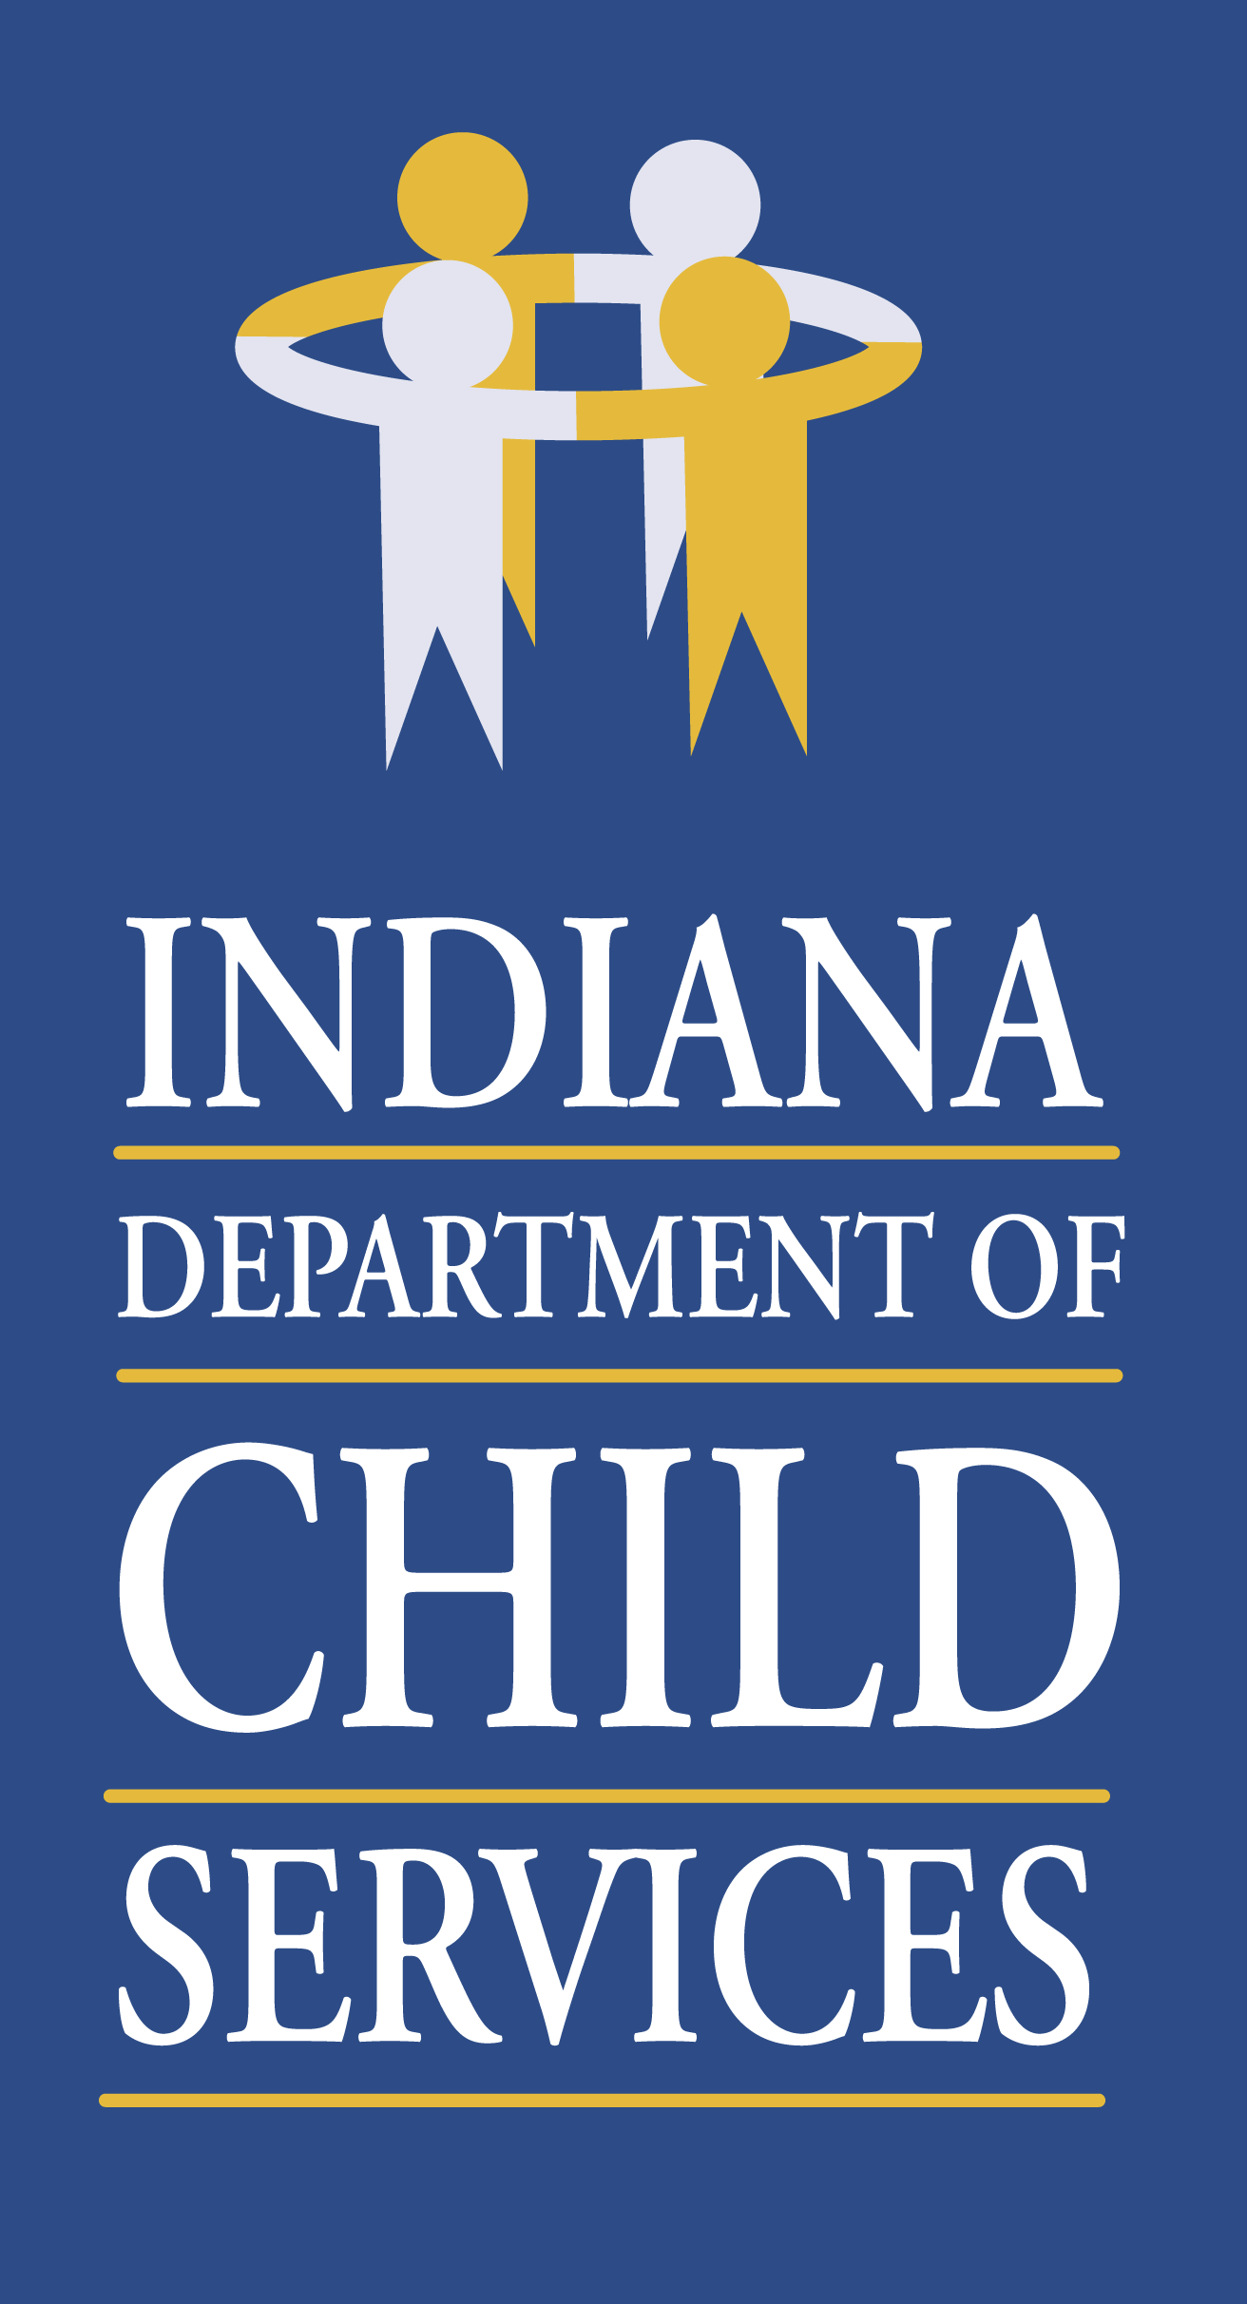

INDIANA DEPARTMENT OF CHILD SERVICES

Request for Proposal 10000184

Addendum #2

Solicitation For:
Child Advocacy Center (CAC) Services

Response Due Date: May 1, 2020

Indiana Department of Child Services
DCS Child Welfare Services
302 W. Washington St., Room E306
Indianapolis, Indiana 46204
Summary of Changes

- Attachment O – (Optional) CJA Service Narrative
  - Has been reposted as a Word document to assist in completing the attachment.

