MEMORANDUM
TO: IPDC Board
FROM: Bernice A. N. Corley, Executive Director
DATE: March 4, 2021
RE: 2021 Annual Retreat - Date setting
In recent years, IPDC Board has scheduled the Annual Retreat to coincide with the Indiana Judicial Conference as a way of mitigating scheduling conflicts for Board members and trial/hearing schedules. The 2021 Judicial Conference is September 1st – 3rd. IPDC has the following events during September:
- 9/12-15: Joint event with NAPD (location is not yet set);
- 9/20-23: TPD (Brown County); and
- 9/30-10/1: Paula Sites Capital Defense Seminar (Brown County)
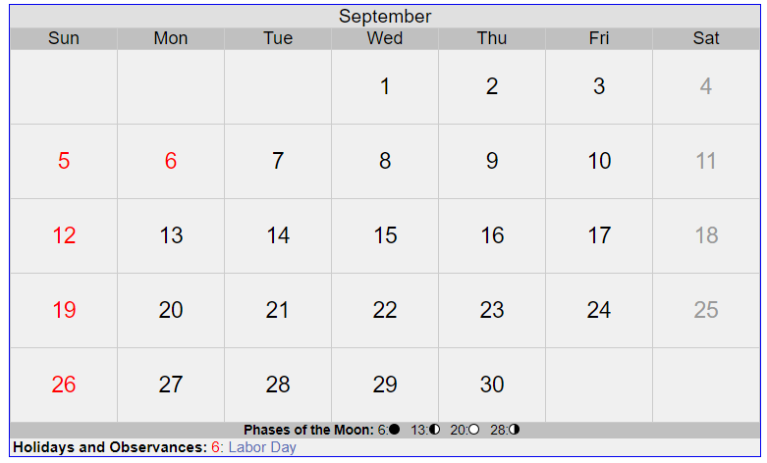
There are no events in October which would be a conflict to scheduling the Annual Update.

